[**How to convert VMDK to a Docker image**](https://stackoverflow.com/questions/31321076/how-to-convert-a-vagrant-box-to-a-docker-image)

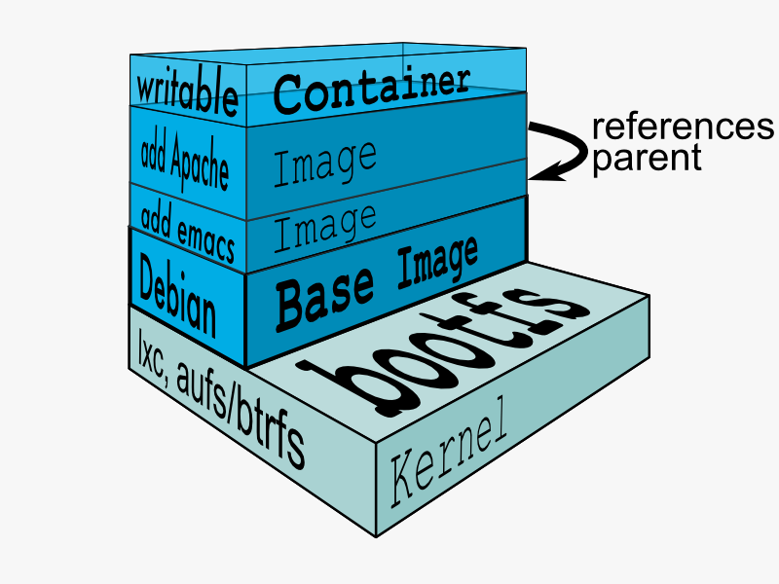

qemu-img convert -f vmdk -O raw MyImage-disk1.vmdk myimage.img

Next, After the raw has been created you can apply Guestfish:

$ guestfish -a myimage.img --ro  
$ ><fs> run

$ ><fs> list-filesystems   
/dev/sda1: ext4  
/dev/VolGroup/lv_root: ext4  
/dev/VolGroup/lv_swap: swap  
$ ><fs> mount /dev/VolGroup/lv_root /  
$ ><fs> tar-out / - | xz --best >> myimage.xz  
$ ><fs> exit

Now, Importing myimage.xz into docker:

$ cat mytry.xz | docker import - mydockerimage

Next, Look inside the container:

$ docker run -it mydockerimage bash

It’s work!!!!!

Ref : <https://stackoverflow.com/questions/31321076/how-to-convert-a-vagrant-box-to-a-docker-image>